EUROCAT F: New front drum mowers
Focus on smooth running and cost effectiveness

As the specialist in grassland farming, Pöttinger has updated its extensive range of mowers for the new season and added new models. A lot has been happening with the drum mowers. The EUROCAT F front mowers see Pöttinger offer particularly smooth running and cost effective solutions. The working widths on the new models are 2.70 m and 3.05 m.

Cost effective and strong
The EUROCAT F series delivers an impressive mix of low weight and the highest strength. The compact three-point headstock shifts the centre of gravity very close to the tractor. This means that lighter tractors can also be used. The mower also handles extremely well when working on steep terrain.

The best cutting quality
Four equally sized mower drums guarantee the best working results in all conditions. The arc of the blades is the same for all four drums, which ensures a clean and tidy cutting pattern. The large mower drums in the centre provide plenty of clearance. In addition, the two middle drums have a narrower neck, which provides even more space. Each drum has the same area of ground contact. This equal distribution of pressure ensures perfect ground tracking. Gimbals in the guide arms of the mower unit guarantee multidimensional freedom of movement. The arc of movement of +/- 8 degrees allows the mower to float over all undulations in the ground. The weight of the mower is carried either by the tractor hitch, or optionally by two strong suspension springs between the headstock of the mower and the mounting bracket on the tractor.

Convenient and user friendly
The continuously variable PLUS cutting height adjustment system offers maximum convenience. The cutting height of all the drums can be adjusted from a central point between 40 mm and 65 mm. The side guards are folded upwards for safe road transport, and hydraulic folding is available as an option. The guards fold well away to provide optimum access to the mower drums, making it possible to clean the machine thoroughly and change blades quickly and easily.

NOVACAT F front mowers made by Pöttinger offer a combination of cost effectiveness, the best cutting quality and convenience, which is perfect for handling diverse scenarios in the field.

Photo preview:

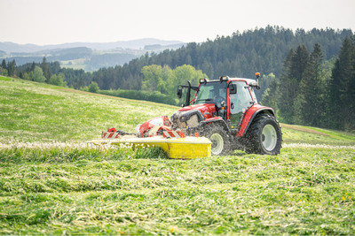 | 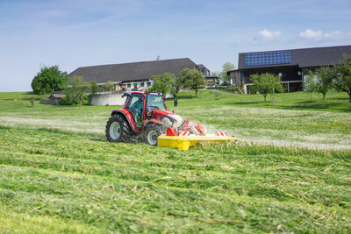
EUROCAT F3100P, the smooth front mower | EUROCAT F drum mower for cost effective mowing
https://www.poettinger.at/de_at/newsroom/pressebild/135618 | https://www.poettinger.at/de_at/newsroom/pressebild/135617

More printer-optimised photos: www.poettinger.at/presse

